Tableau Day 1 - Exercises with Answers

Exercise 1

For each of the following data visualizations, identify the relevant **chart type** and the **data type(s)** from the following bank of options.

|  |  |
| --- | --- |
| **Chart type** | **Data type** |
| Bar chart  Line chart  Area chart  Heatmap  Scatterplot  Histogram  Map | Univariate data  Bivariate data  Multivariate data  Trend data  Text data  Geospatial data |

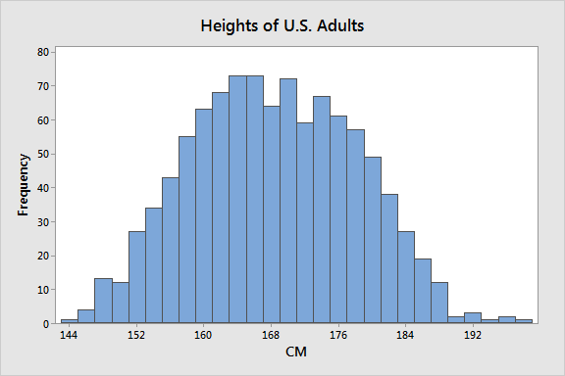

Answer: univariate histogram (frequency of height in cm)

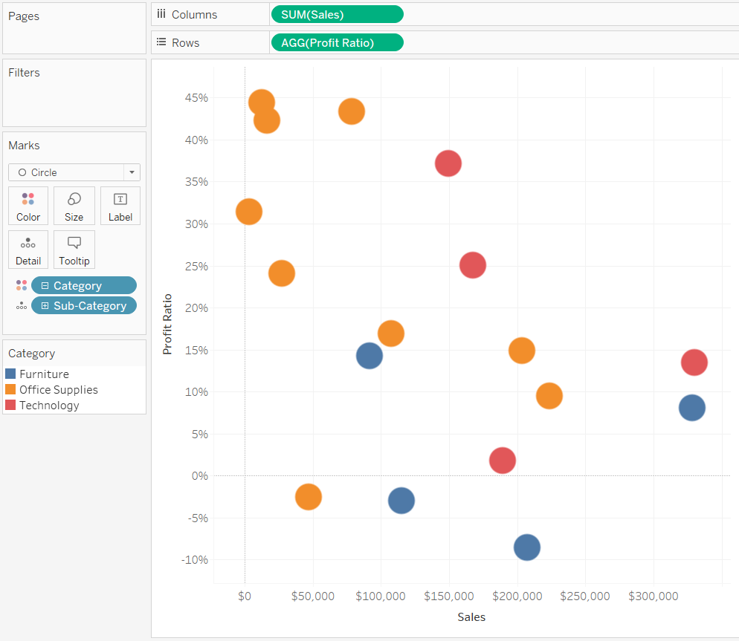

Answer: multivariate scatterplot (sales, profit ratio) with category as a color marker

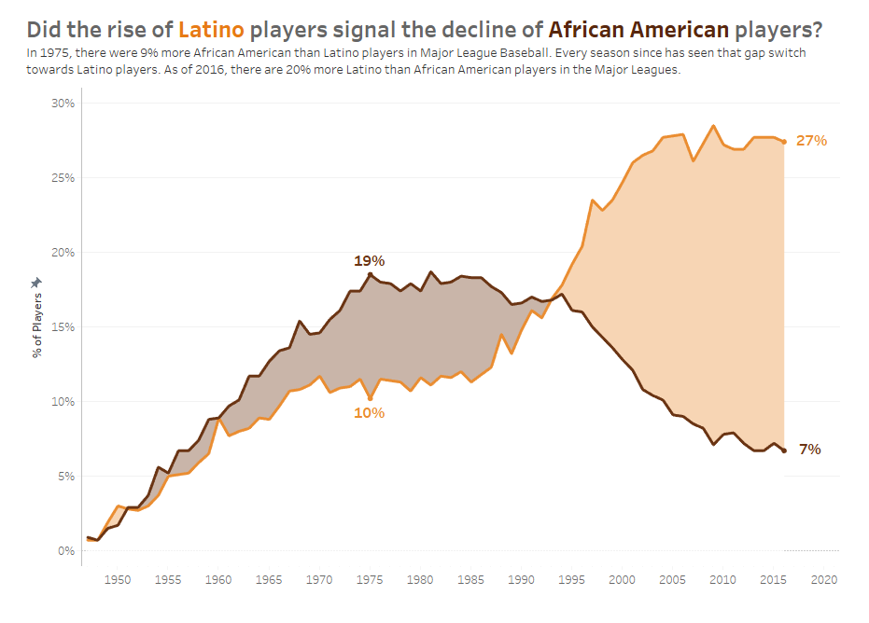

Answer: bivariate (stacked) area chart (% of players, race over time) -- trend data is also an acceptable answer

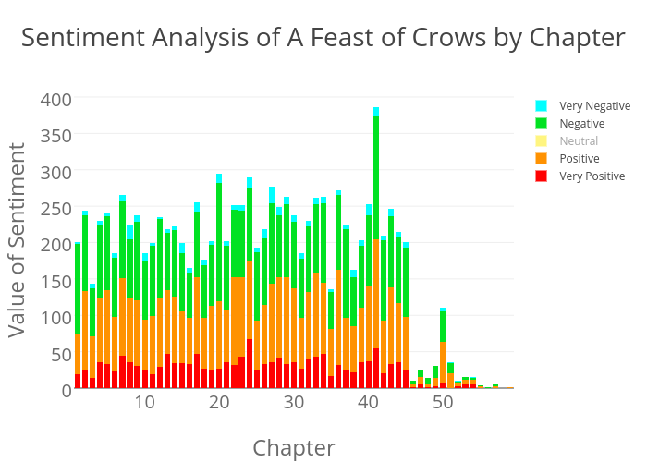

Answer: bivariate text data in a (stacked) bar chart (sentiment and value by chapter)

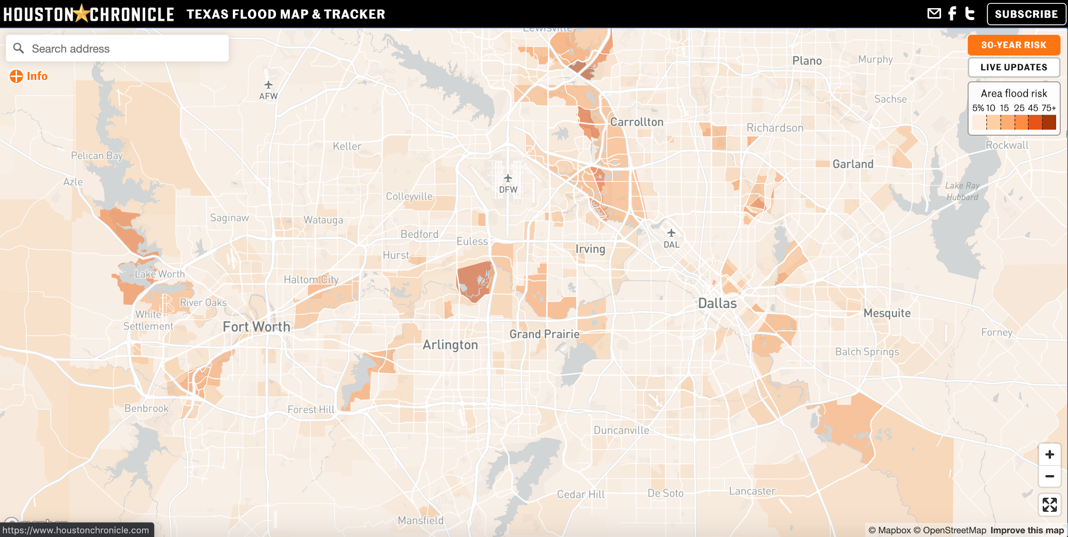

Answer: univariate geospatial data in map (area flood risk)

Exercise 2

1. Consider the following (confusing) charts:

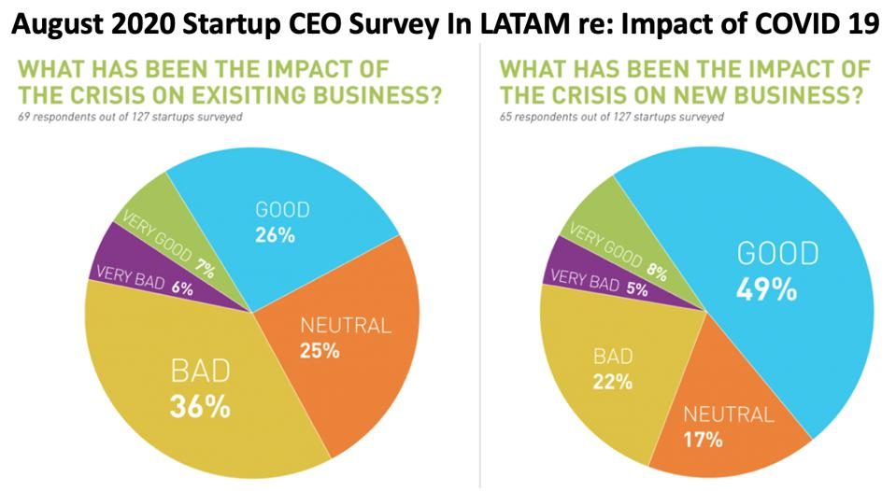

Setting aside their other problems, how might you use **color** to re-encode this data differently? Would you use a **sequential, diverging, or categorical** color scheme? Why?

Answer:

The current categorical color scheme does nothing to reinforce the scale of responses here, from very bad to very good. The best option here is to use a **diverging** color scheme with “neutral” in the middle, so that “good” and “very good” are related hues and “bad” and “very bad” are related hues.

1. Consider the following (confusing) chart:

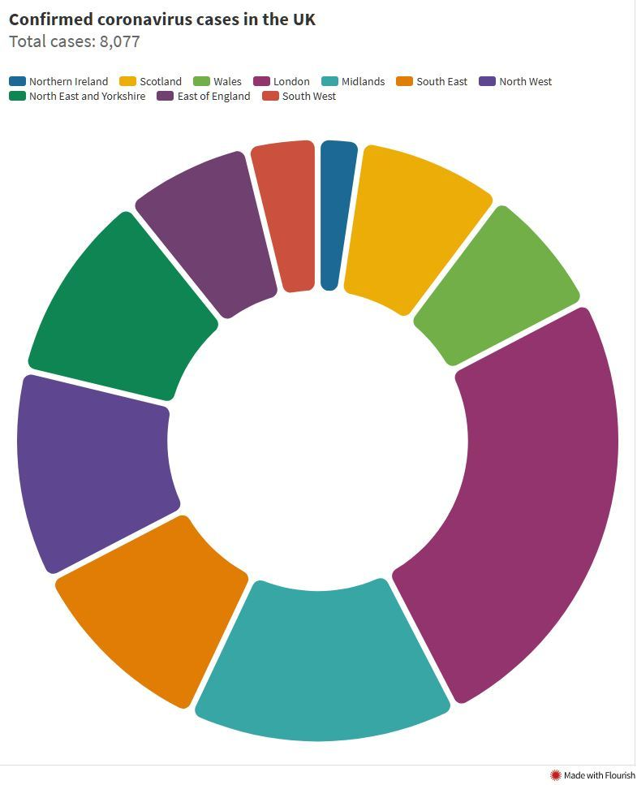

Setting aside its other problems, how might you use **position, labels, and color** to make this chart more easily interpretable? Is there any additional data you might like to add or represent in some way?

Answer:

Because the categorical colors have been chosen randomly, users have to shift attention 10 separate times between the legend and the chart. Each wedge of the donut could be directly labeled, either on top of the wedge or at a nearby position. Using position in this way would allow for less variation in color. Each wedge could also be labelled with a corresponding percentage and/or raw case count number, with the total number of cases in the middle. In addition, you could even color the wedges based on their count of the cases.

1. Consider the following (confusing) chart:

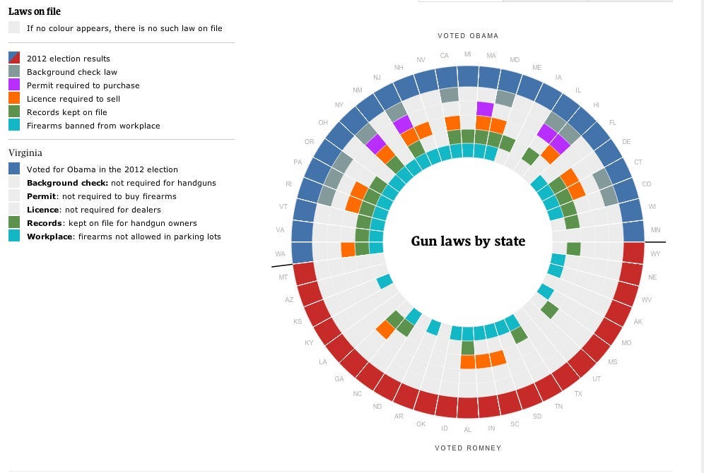

What might you change about how the data has been represented to make it easier to interpret? Consider the basic building blocks of visual design: **size, shape, position, labels / legends, and color**.

Answer:

Since all of the data in this chart is categorical, the round shape is purely aesthetic rather than quantitative. The data might actually be best represented as a table of 50 rows (1 for each state) and 6 columns (1 for each law, plus the 2012 election results). The only “necessary” color here is red/blue for election results, though you could get away with a simple “R” or “D.” All other table fields could simply be check marks or empty cells. By splitting the data into two separately titled tables – 1 for Obama-won states and 1 for Romney-won states – you could eliminate color entirely.

**Chart source information:**

<https://statisticsbyjim.com/basics/histograms/>

<https://playfairdata.com/3-ways-to-make-stunning-scatter-plots-in-tableau/>

<https://www.thedataschool.co.uk/timothy-manning/shading-in-between-two-lines-in-tableau-using-area-charts-tableau-tips-with-tableautimothy>

<https://chart-studio.plotly.com/~skchandra/404/sentiment-analysis-of-a-feast-of-crows-by-chapter.embed>

<https://www.houstonchronicle.com/projects/trackers/houston-flood-map/>

-----

<https://junkcharts.typepad.com/junk_charts/2020/10/making-better-pie-charts-if-you-must.html>

<https://viz.wtf/post/615124174187413504/ah-perfect-10-different-colors-that-i-have-to-go>

<https://www.theglobeandmail.com/news/world/gun-control-in-america-a-state-by-state-breakdown/article6465107/?ranMID=46474&ranEAID=TnL5HPStwNw&ranSiteID=TnL5HPStwNw-uLDS982sCQupg9MFp.2GXQ>